Quickdress
Milestone 1: Scoping, Requirements and Architecture
Submission document
Revised November 5, 2026 (first submitted October 13, 2026)
Team
Aya Noaman, Malk Metwally, Nada Salem, Marwan Abouelfotuh, Omar Hassan
Project links
GitHub: https://github.com/marwanabouelfotuh-gif/Quickdress
Jira: https://swe-quickdress-project.atlassian.net

Contents of this submission
This document brings together everything submitted for Milestone 1. Each part keeps its own section, figure and table numbering, so references such as "Figure 2" or "Table 4" point to the figure or table in the same part.
This is a revised version that answers the instructor's comments on the first submission. The architecture is now a microkernel (plug-in) architecture instead of a layered one, and every statement that lacked evidence or a plan now has a rule, a source or a test behind it. Each specification starts with a short note on what changed.
Deliverable | What it contains | Where
Requirements Specification | System overview, users and stakeholders, product backlog (22 functional, 11 non-functional requirements), scope and sprint plan, use case diagram and descriptions, global and social considerations. | Part A
Design Specification | Microkernel architecture: component diagram, core components, plug-in contracts and plug-ins, events, sequence diagrams, recommendation rules, quality attributes with a test plan, patterns, class diagram, build order with exit criteria, and risks. | Part B
Presentation | A 17-slide deck for the 20-minute talk, with speaker notes, in Quickdress_Milestone1_Presentation.pptx (and PDF). Part C maps each required topic to its slide. | Separate file and Part C
GitHub repository | Both specifications (Word and PDF), every diagram as an image, and this document, in the "Milestone 1 (revised)" folder, next to the original "Milestone 1" folder. https://github.com/marwanabouelfotuh-gif/Quickdress | Link
Jira project | Product backlog and sprint board. https://swe-quickdress-project.atlassian.net | Link
Milestone 1 deliverables.

Who prepared what
Document | Prepared by
Requirements Specification (Part A) | Omar Hassan
Design Specification (Part B) | Marwan Abouelfotuh
Contributions by Aya Noaman, Malk Metwally and Nada Salem are tracked on the Jira board.
Part A
Requirements Specification
Quickdress: Requirements Specification
Milestone 1 · Scoping, Requirements and Architecture · Revised November 5, 2026
Prepared by Omar Hassan
Team: Aya Noaman, Malk Metwally, Nada Salem, Marwan Abouelfotuh, Omar Hassan

What changed in this revision
This revision answers the instructor's comments on the first version (October 13, 2026). The architecture is now a microkernel (see the Design Specification), so the sentences that described the old layered design were updated. Statements that had no evidence or plan behind them were fixed:
- The comparison with Cladwell, Whering and Acloset (section 1.5) was wrong: Cladwell and Acloset already suggest daily outfits from the weather. It now cites their own descriptions and states what Quickdress does differently, plus how we will check it.
- The "10 minutes to 10 seconds" figure (section 1.2) had no source and was removed. The Sprint 2 usability test will time it instead.
- Stretch goals are no longer built "if capacity remains". Section 3.4 gives the rule that decides it, and each sprint has exit criteria.
- Social and environmental claims (section 5) now rely only on requirements that are in scope, or say clearly when a feature is a stretch goal or deferred.

Contents
- System overview
- Product backlog
- Scope of the project
- Use cases
- Global, cultural, social, environmental, economic, public health, safety and welfare considerations
- Conclusion
- References

1 System overview
Quickdress is an iOS app that photographs a user's wardrobe once, then recommends a complete outfit from those clothes every morning, matched to the day's weather and calendar.

1.1 What it is
The user captures each clothing item with the phone camera. Quickdress stores the item with its attributes (type, colour, warmth, formality, comfort). Each morning the app presents one outfit for the day; the user can swap a single piece or request a new combination. Everything runs on the device: SwiftUI, SwiftData and a rule-based recommender. The app is built as a small core with plug-ins (see the Design Specification), so other recommenders can be added later without changing the screens. An optional step that asks Google's Gemini model for a suggestion is off by default and runs only if the user turns it on (FR-22).

1.2 Purpose and the problem it solves
Choosing clothes is a daily, repeated decision that costs time and causes decision fatigue. People repeat the same few outfits, forget items they own, and dress for the wrong weather or occasion. Quickdress removes the decision: the user confirms one suggested outfit made only from clothes they already own. We have not measured how long the choice takes today. The Sprint 2 usability test (NFR-04) will time five people choosing an outfit with and without the app.

1.3 Users
User | Need | How Quickdress serves it
University students | Little time in the morning, variable daily schedule (lectures, gym, events) | Calendar-aware outfit each morning
Young professionals | Dress codes that change by meeting; want to avoid repeating outfits in front of colleagues | Formality filter, repeat tracking
People with decision anxiety | Too many choices causes stress | One recommendation, not a catalogue
People unsure about colour matching (including colour-vision deficiency) | Cannot judge which colours go together | Colour matching handled by the recommender

1.4 Stakeholders
Stakeholder | Interest
End users (above) | A fast, trustworthy daily recommendation; privacy of wardrobe photos and calendar
Development team (Aya, Malk, Nada, Marwan, Omar) | Deliverable scope within the course timeline; learning Swift
Course instructor and TAs | Clear requirements, sound architecture, evidence of process (Jira, GitHub)
Apple (platform owner) | App Store guidelines, permission rules for camera, calendar and location
Weather data providers (Open-Meteo; Apple WeatherKit if a team member has an Apple Developer membership) | API usage within quota and terms
Google (Firebase AI Logic and the Gemini API) | Only if the opt-in AI step (FR-22) is built: API usage within quota and terms. It receives anonymised item attributes, never photos, calendar text or location.

1.5 Motivation
Quickdress is not the first app to suggest outfits from clothes the user owns. Cladwell's own guide says it sends three outfit suggestions based on the user's closet and the weather [1], and Acloset's App Store listing describes daily suggestions tailored to the weather and the user's schedule [2]. Whering is another digital wardrobe app in the same category. Quickdress differs in four design choices:
- Everything stays on the phone, with no account and no server of our own (NFR-02), and outfits are produced offline (NFR-03).
- Filters for the user's actual day: mode of transport (walking in the heat versus an air-conditioned car) and comfort priority (FR-10).
- Formality from the calendar that the user can correct, by tagging an event as formal or setting an override (FR-11).
- It is free, with no in-app purchases and no links to shops.
We have not found transport or comfort filters in these apps' public descriptions, but descriptions can be incomplete. In Sprint 1 the team will install Cladwell, Whering and Acloset, use each for one day, and record which of the four points above each app already covers. This section will be updated from that check.
The plan does not assume any prior iOS experience: the first sprint keeps to SwiftUI and SwiftData basics that Apple's own tutorials cover. Risk R3 in the Design Specification covers the rest of the learning curve.

2 Product backlog
The backlog lists everything the team has identified, including items that will not fit this term. Priority follows MoSCoW; Section 3 draws the implemented scope from the Must and Should rows.

2.1 Functional requirements
ID | Epic | Requirement | Priority
FR-01 | Wardrobe capture | The user shall add a clothing item by taking a photo or choosing one from the photo library. | Must
FR-02 | Wardrobe capture | The system shall store each item with attributes: category (top, bottom, outerwear, shoes, accessory), colour, warmth level, formality level, comfort level, and season. | Must
FR-03 | Wardrobe capture | The user shall be able to edit or delete any stored item. | Must
FR-04 | Wardrobe browsing | The user shall be able to view the wardrobe as a grid, filtered by category and colour. | Must
FR-05 | Daily outfit | The system shall generate one complete outfit (top, bottom, shoes, plus outerwear when needed) each day from the user's own items. | Must
FR-06 | Daily outfit | The user shall be able to replace any single piece in the recommended outfit with an alternative suggestion. | Must
FR-07 | Daily outfit | The user shall be able to request a completely new outfit. | Must
FR-08 | Weather | The system shall fetch the day's forecast for the user's location and use temperature and precipitation when choosing warmth level and outerwear. | Must
FR-09 | Daily outfit | The user shall be able to mark an outfit as worn, and the system shall avoid repeating a worn outfit within a configurable number of days. | Should
FR-10 | Custom filters | The user shall be able to set daily filters: mode of transport (walking, public transport, car), comfort priority, and formality override. | Should
FR-11 | Calendar | The system shall read the day's events from the iOS Calendar (with permission) and raise the outfit's formality when an event is tagged formal, such as a presentation or interview. | Should
FR-12 | Saved outfits | The user shall be able to compose and save their own outfits for the recommender to reuse. | Should
FR-13 | Wardrobe capture | The system shall suggest the category and dominant colour of a photographed item automatically, which the user may correct. | Should
FR-14 | Daily outfit | The system shall send a morning notification at a user-chosen time with the day's outfit. | Could
FR-15 | Insights | The system shall show which items have not been worn in the last 30 and 90 days. | Could
FR-16 | Daily outfit | The user shall be able to rate a recommended outfit, and the recommender shall learn from ratings. | Could
FR-17 | Wardrobe capture | The system shall remove the photo background so items display consistently. | Could
FR-18 | Travel | The user shall be able to generate a packing list for a trip of N days at a destination. | Won't (this term)
FR-19 | Social | The user shall be able to share an outfit image with friends. | Won't (this term)
FR-20 | Laundry | The system shall track items currently in the laundry and exclude them from recommendations. | Won't (this term)
FR-21 | Multi-device | The wardrobe shall sync across the user's devices via iCloud. | Won't (this term)
FR-22 | AI suggestions | The user shall be able to turn on AI suggestions. When they are on, the system may ask an external model (Gemini) for an outfit, sending only anonymised item attributes and the day's conditions. | Could

2.2 Non-functional requirements
ID | Quality | Requirement | Priority
NFR-01 | Performance | The daily outfit screen shall be visible within 2 seconds of opening the app on an iPhone 12 or newer. | Must
NFR-02 | Privacy | Wardrobe photos, item data and calendar information shall be stored and processed on the device only; no personal data leaves the phone without explicit user consent. | Must
NFR-03 | Availability (offline) | Wardrobe browsing and outfit generation shall work with no network connection, using the last fetched forecast. | Must
NFR-04 | Usability | A new user shall be able to add their first item and receive an outfit within 5 minutes, without instructions. | Must
NFR-05 | Performance | Generating an outfit for a wardrobe of up to 200 items shall take under 1 second. | Should
NFR-06 | Reliability | The app shall not lose any stored item or photo across app updates or force-quits. | Should
NFR-07 | Security | Access to the Camera, Photos, Calendar and Location shall each be requested only when first needed, with an explanation, and the app shall remain usable if any permission is denied. | Should
NFR-08 | Maintainability | The recommendation engine shall be behind a single interface so the on-device model can be swapped for an API-based model without changing the UI. | Should
NFR-09 | Accessibility | All screens shall support VoiceOver labels and Dynamic Type up to the Accessibility XL size. | Could
NFR-10 | Compatibility | The app shall support iOS 17 and later. | Could
NFR-11 | Localisation | UI strings shall be externalised so Arabic can be added without code changes. | Could

3 Scope of the project
The team commits to the 11 functional requirements FR-01 to FR-11 and the 8 non-functional requirements NFR-01 to NFR-08. FR-12, FR-13 and FR-22 are stretch goals, built in Sprint 3 only under the decision rule in section 3.4. Everything else in the backlog is deferred.

3.1 Functional requirements in scope
Group | Requirements | Why in scope
Wardrobe capture and browsing | FR-01, FR-02, FR-03, FR-04 | Without a stored wardrobe nothing else works; this is the foundation.
Daily outfit | FR-05, FR-06, FR-07 | The core promise of the product: open the app, see today's outfit.
Weather | FR-08 | The first custom filter and the simplest external integration (Open-Meteo needs no key; WeatherKit is used if the team has a developer membership).
Context filters | FR-09, FR-10, FR-11 | These are the differentiators named in the pitch: no repeats, transport and comfort filters, calendar awareness.
Stretch | FR-12, FR-13, FR-22 | Saved outfits, automatic attribute suggestion and the opt-in Gemini step improve the experience, but the app is complete without them. Built only under the decision rule in section 3.4.

3.2 Non-functional requirements in scope
NFR-01 to NFR-08: performance (2 s to first screen, 1 s to generate), on-device privacy, offline operation, 5-minute first-run usability, data durability, permission handling, and a swappable recommendation engine. NFR-09 to NFR-11 (accessibility, iOS version floor, localisation) are followed as good practice but not formally tested this term.

3.3 Out of scope this term
FR-14 to FR-21: notifications, wear insights, rating-based learning, background removal, travel packing, social sharing, laundry tracking and iCloud sync. Each needs either a server, extra ML work, or an additional Apple framework, and none is required to prove the concept.

3.4 Why the scope is achievable
The scope is split into three sprints, one per remaining course milestone. Each sprint ends at that milestone with a working app that can be demonstrated, and counts as done only when its exit criteria pass (Design Specification, Table 8). The riskiest work, the outfit engine, is in Sprint 2, so Sprint 3 still leaves room to recover.
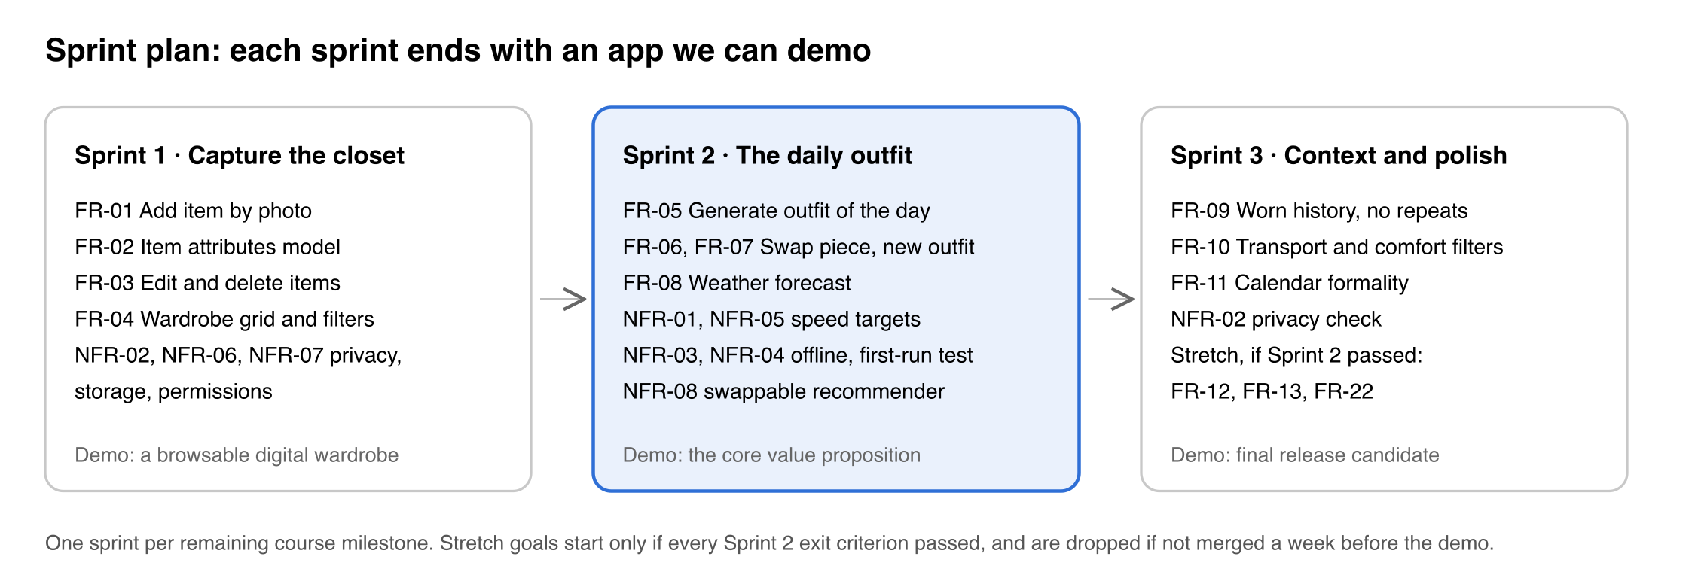
Figure 1. Sprint plan: three sprints, one per remaining milestone.
Sprint 1 is mostly SwiftUI and SwiftData create, read, update and delete work, which suits a team that is learning Swift. Sprint 2 is the outfit engine. Its recommender is rule-based scoring over item attributes, with every rule and weight written out in section 2.2 of the Design Specification, not a trained model, which keeps machine learning off the critical path. Sprint 3 adds the calendar and two more filters, each a small plug-in.
Stretch goals follow one rule. They are started only if every Sprint 2 exit criterion has passed when Sprint 3 begins. They are then built in the order FR-12, FR-13, FR-22, and any stretch goal that is not merged one week before the Sprint 3 demo is dropped.
The plan is tied to the course milestones, not to calendar dates, because the team has not fixed sprint dates yet. When each sprint starts, its start and end dates are entered on the Jira board.

4 Use cases
Quickdress has one primary actor, the User, and three secondary actors that the system calls: a weather service (Open-Meteo, or Apple WeatherKit if available), the iOS Calendar (EventKit) and, only when the user has turned on AI suggestions, Google's Gemini model through Firebase AI Logic. The diagram covers the in-scope requirements FR-01 to FR-11 and the stretch requirement FR-22.
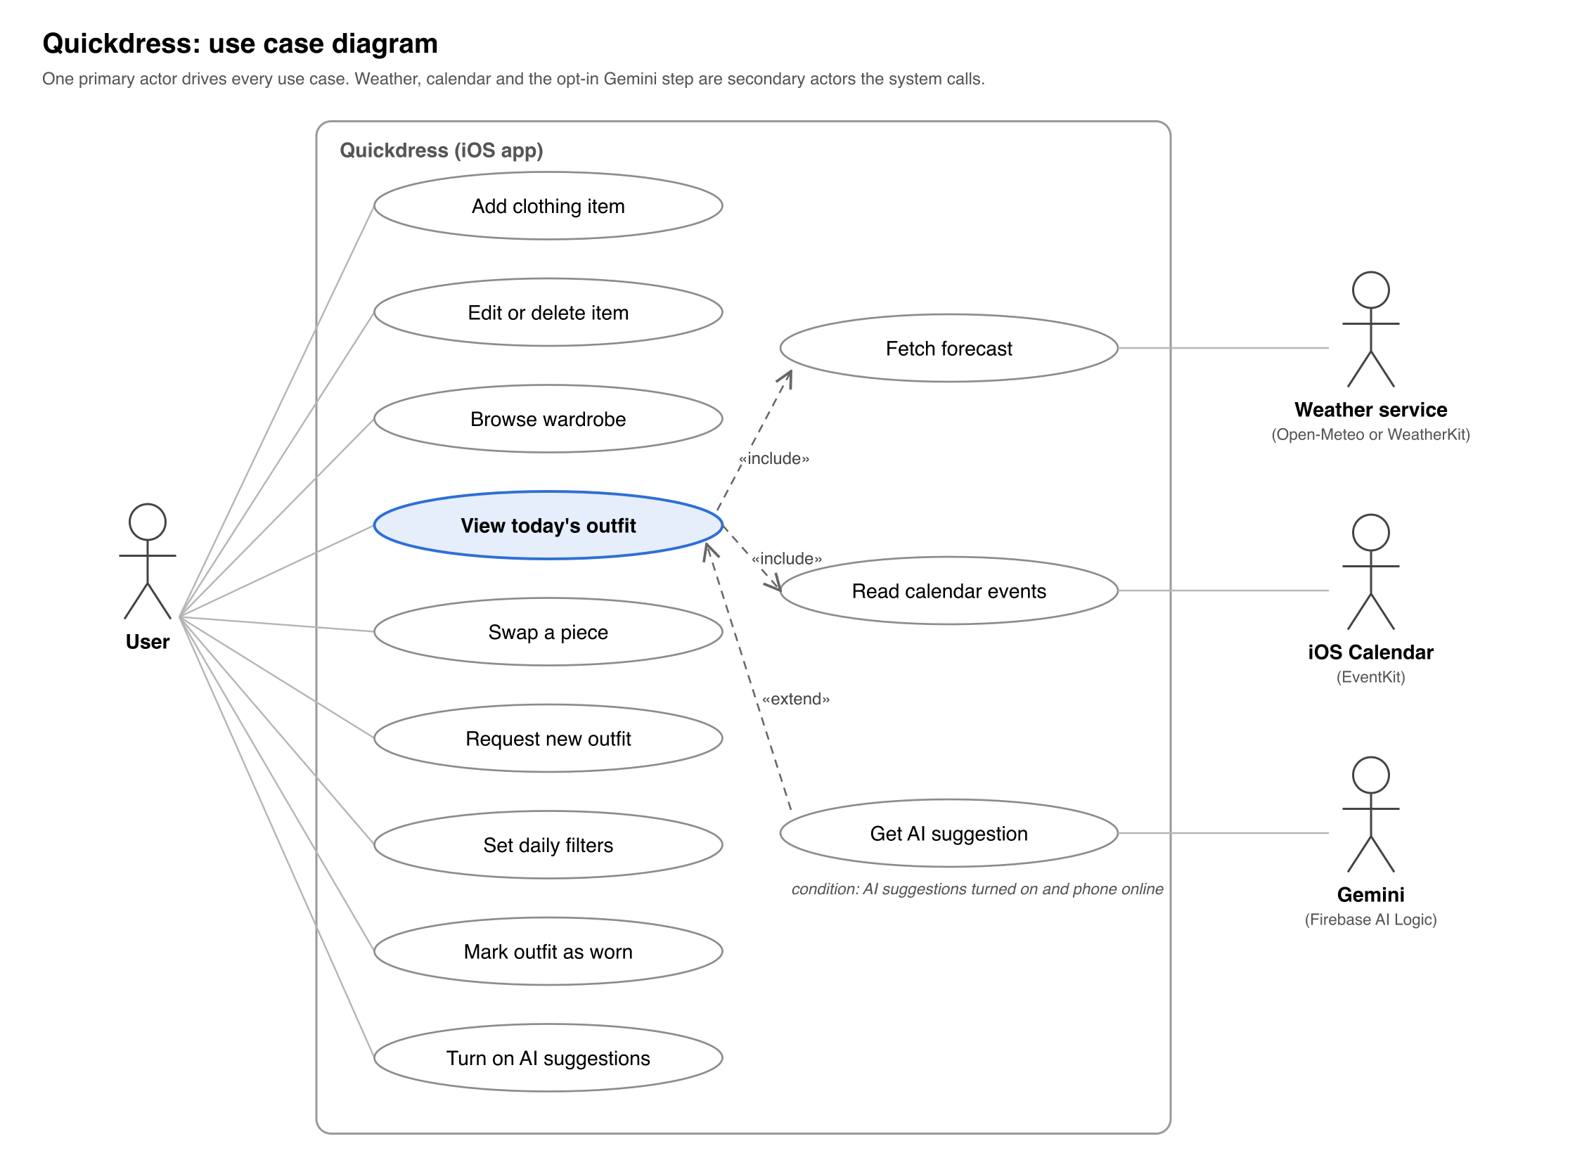
Figure 2. Use case diagram: one primary actor, three secondary actors, twelve use cases.
Viewing today's outfit always includes fetching the forecast and reading calendar events; if either permission is denied the use case still completes with defaults (NFR-07). Getting an AI suggestion extends it only when the user has turned the feature on and the phone is online.

4.1 Use case descriptions
Use case | Actor | Precondition | Main flow | Postcondition | Requirements
Add clothing item | User | Camera or Photos permission granted | 1. User taps Add.  2. Takes or picks a photo.  3. Sets category, colour, warmth, formality, comfort, season.  4. Saves. | Item stored locally with photo and attributes | FR-01, FR-02
Edit or delete item | User | Item exists | 1. User opens an item.  2. Changes attributes or taps Delete.  3. Confirms. | Item updated or removed; outfits containing it are invalidated | FR-03
Browse wardrobe | User | At least one item | 1. User opens Wardrobe.  2. Filters by category or colour.  3. Taps an item for detail. | None | FR-04
View today's outfit | User | At least one top, bottom and pair of shoes stored | 1. App opens on Today.  2. System fetches forecast and calendar (included).  3. Recommender scores combinations and shows the best one. | Outfit of the day displayed and cached | FR-05, FR-08, FR-11, NFR-01
Swap a piece | User | Outfit displayed | 1. User taps a piece.  2. System offers the next best alternatives for that slot.  3. User picks one. | Outfit updated | FR-06
Request new outfit | User | Outfit displayed | 1. User taps New outfit.  2. System generates the next best full combination. | Outfit replaced | FR-07
Set daily filters | User | None | 1. User opens Filters.  2. Sets transport mode, comfort priority, formality override.  3. Applies. | Recommendation regenerated with the filters | FR-10
Mark outfit as worn | User | Outfit displayed | 1. User taps Wearing this. | Outfit logged with today's date; excluded from recommendations for the configured period | FR-09
Turn on AI suggestions | User | None | 1. User opens Settings.  2. Reads what data would be sent.  3. Turns on AI suggestions. | Consent stored; the Gemini step may run when online | FR-22, NFR-02
Fetch forecast | System (weather service) | Location permission granted, network available | 1. System requests today's hourly forecast.  2. Stores it locally. | Forecast cached; last forecast used when offline | FR-08, NFR-03
Read calendar events | System (EventKit) | Calendar permission granted | 1. System reads today's events.  2. Detects formal keywords or user tags. | Formality level for the day set | FR-11
Get AI suggestion | System (Gemini) | AI suggestions on and network available | 1. System sends anonymised item attributes and the day's conditions.  2. Gemini returns one item per slot.  3. System checks the reply against the wardrobe. | Outfit returned; on any failure the rule-based recommender answers instead | FR-22, NFR-02, NFR-03

5 Global, cultural, social, environmental, economic, public health, safety and welfare considerations
The most significant consideration is privacy: Quickdress holds photographs of a person's clothes, their location and their calendar. Processing everything on the device (NFR-02) is a design decision made because of this, not only for performance.
Area | Consideration | How the requirements respond
Privacy and security | Wardrobe photos, calendar entries and location reveal daily routine and whereabouts. | On-device storage and inference (NFR-02); permissions requested one at a time with an explanation and the app usable without them (NFR-07); no account, no server of our own, no analytics. The only external AI call (FR-22) is off by default and sends anonymised attributes only.
Public health and safety | Dressing for the wrong weather causes discomfort and, in Cairo summers, heat-related risk; morning decision stress is a small daily wellbeing cost. | Weather-driven warmth and outerwear choice (FR-08); one recommendation instead of a catalogue (FR-05) to reduce decision fatigue.
Cultural and social | Dress norms differ by religion, workplace and family; modest dress, hijab-compatible combinations and local occasions (Eid, Ramadan iftars, university events) are common for the target users. The recommender must not impose a single Western style norm. | Formality and comfort are user-defined attributes, not inferred from fashion datasets (FR-02); if the stretch goal FR-12 is built, the user can also save their own outfits as examples; no body-shape or appearance scoring anywhere in the backlog.
Environmental | Fast fashion is driven partly by people feeling they have nothing to wear. | Quickdress recommends only from what the user owns and favours items that have not been worn recently (the freshness score, Design Specification section 2.2), which encourages re-wearing instead of buying. A screen that lists unworn items (FR-15) is deferred.
Economic | Target users are students and early-career professionals with limited budgets. | The app is free, has no in-app purchases, and never links to shopping. Development cost is low: first-party Apple frameworks and no server hosting. Weather comes from the free Open-Meteo API, with WeatherKit used only if a team member already has the paid Apple Developer membership, and the opt-in Gemini step uses Google's lowest-cost model.
Global and accessibility | The first release is English-only and iOS-only, which limits reach in Egypt where Android dominates. Colour matching is a real barrier for users with colour-vision deficiency. | Strings externalised for Arabic (NFR-11); VoiceOver and Dynamic Type (NFR-09); colour matching handled by the system so the user never has to judge colours. Android is noted as a future direction, not a requirement.
Public welfare | A recommender that nudges users towards particular clothes could be exploited for advertising. | NFR-02 rules out third-party data sharing without consent, and the scope contains no monetisation feature or commercial recommendations.

6 Conclusion
Quickdress solves a small but daily problem, choosing what to wear, by recommending one outfit from the user's own wardrobe, matched to the weather and the day's calendar. This document fixes the Milestone 1 baseline: a backlog of 22 functional and 11 non-functional requirements, a committed scope of FR-01 to FR-11 and NFR-01 to NFR-08 with FR-12, FR-13 and FR-22 as stretch goals, twelve use cases, and a three-sprint plan in which each sprint ends with a demonstrable app. The accompanying Design Specification shows how the microkernel architecture, a small core with plug-ins for capture, storage, context, filters and recommenders, meets the non-functional requirements committed here, and how each one will be tested. The next delivery is Sprint 1: a working digital wardrobe with capture, editing and browsing.

7 References
[1] Cladwell, "Getting started with Cladwell". https://cladwell.com/blog/getting-started (accessed November 5, 2026).
[2] Acloset, "Acloset - AI Fashion Assistant", Apple App Store listing. https://apps.apple.com/us/app/acloset-ai-fashion-assistant/id1542311809 (accessed November 5, 2026).
Part B
Design Specification
Quickdress: Design Specification
Milestone 1 · Scoping, Requirements and Architecture · Revised November 5, 2026
Prepared by Marwan Abouelfotuh
Team: Aya Noaman, Malk Metwally, Nada Salem, Marwan Abouelfotuh, Omar Hassan
This document is the companion to the Quickdress Requirements Specification. Requirement IDs (FR-xx, NFR-xx) refer to that document.

What changed in this revision
The first version (October 13, 2026) received two main comments from the instructor. Table 0 shows how this revision answers each one.
Comment | What we changed
A layered architecture is too simple for our app. | The app is now a microkernel (plug-in) architecture: a small core plus plug-ins for capture, storage, context, filters and recommenders, with an in-process event bus. Outfit generation is a pipe-and-filter pipeline inside the core. MVVM stays as the design of the screens. Every diagram, table and section that described the layers was rewritten (sections 1 to 7).
We make statements that we do not support with concrete plans. | Every promise now has a rule, a number or a test behind it: the scoring rules and thresholds (section 2.2), the formality keywords (section 2.2), a test plan with a sprint, a tool and a pass mark for each non-functional requirement (Table 6), exit criteria and a decision rule for stretch goals in the build order (Table 8), and a decision point for every risk (Table 9). The Core ML recommender, which had no data or plan behind it, was removed from this term's design.
Table 0. Instructor comments and the changes made.

Contents
- High-level architecture
- Explanation of the architecture
- Quality attributes and how we will test them
- Architectural and design patterns
- Detailed design: class diagram
- Technical feasibility, build order and risks
- Conclusion

1 High-level architecture

1.1 Overview
Quickdress is a single iOS app with no backend of its own. Wardrobe data, photos and calendar information stay on the phone. The app makes only two kinds of network call: one to a weather service for the forecast and, if the user opts in (FR-22), one to Google's Gemini 3.1 Flash-Lite model through Firebase AI Logic.
The app uses a microkernel architecture, also called a plug-in architecture. It has three parts:
- The core system. A small set of components that hold the rules that never change: what a valid clothing item is, how the day's context is put together, and how an outfit is produced. The core also owns the plug-in registry, where plug-ins are registered at launch, and the event bus, which tells interested components when something has happened. The core is plain Swift and imports no Apple framework apart from Foundation.
- Plug-ins. Everything that can vary or be replaced: where photos come from (camera or photo library), where data is stored (SwiftData, files), where the day's information comes from (WeatherKit, Open-Meteo, the calendar), which filters an outfit must pass, and which recommender picks the outfit (rule-based or Gemini). Each plug-in implements a contract (a Swift protocol) defined by the core and never calls another plug-in.
- The host app. The SwiftUI screens, built with MVVM (Model, View, ViewModel), and the composition root (QuickdressApp), which creates every plug-in and registers it with the core. ViewModels call only the core's public services.
The reason for this structure is that most of what is hard about Quickdress is choosing between interchangeable parts at run time. There are two weather sources (R1), two recommenders with a fallback between them (FR-22, NFR-03), two image sources, four outfit filters, and more parts that the backlog already plans for later, such as a laundry filter (FR-20) and iCloud storage (FR-21). In a microkernel these are all the same kind of thing: a plug-in with a priority and an availability check. The core decides which one to use, so adding or removing one does not change the core or any screen (NFR-08).
iOS does not allow an app to download and run new code (App Store Review Guideline 2.5.2), so our plug-ins are not loaded at run time. Each plug-in group is its own Swift package, compiled into the app and registered in code at launch. What makes it a plug-in is that the core depends only on the contract, and the plug-in is chosen by the registry, not by the caller.

1.2 Component diagram
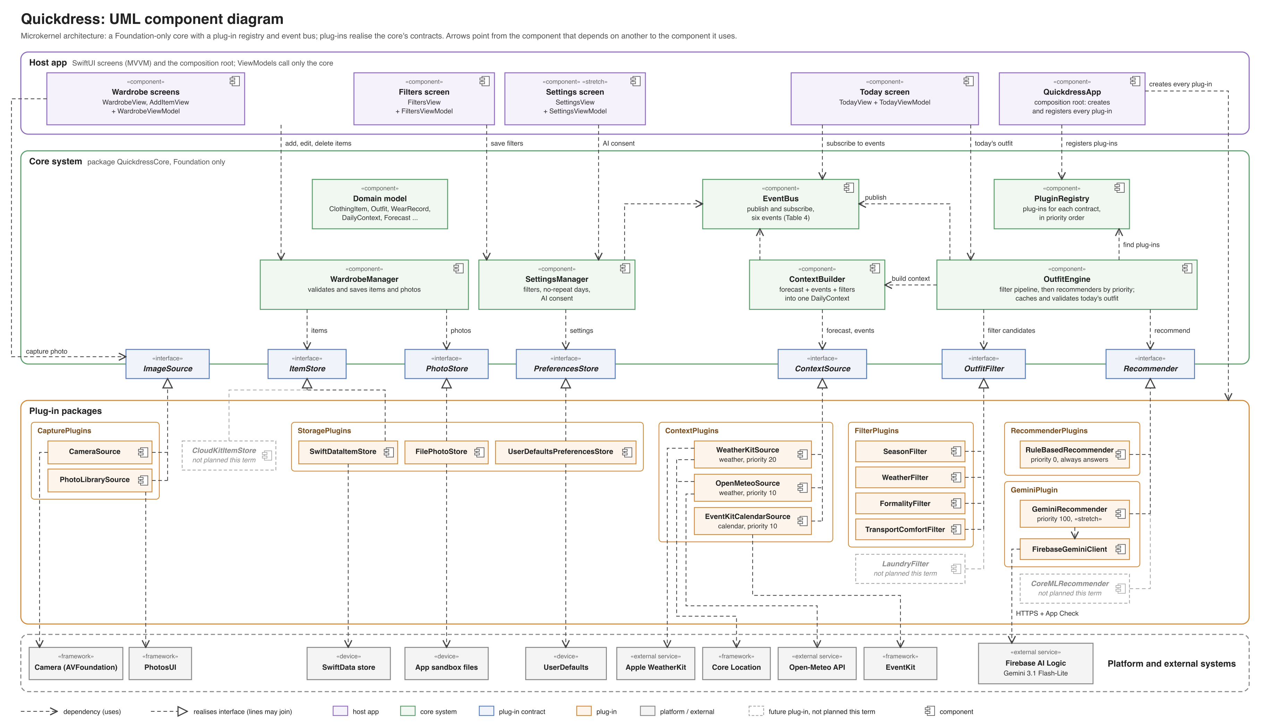
Figure 1. UML component diagram of Quickdress: the core system, its plug-in contracts, the plug-ins that realise them, and the host app.

1.3 The core system
Table 1 lists the components of the core. All of them live in one Swift package, QuickdressCore, which has no dependency on any other package in the project. The compiler therefore stops the core from using a plug-in directly.
Component | Responsibility | Uses | Requirements
PluginRegistry | Holds every registered plug-in. Returns the plug-ins for a contract in priority order, filtered to those that say they are available. For contracts that need exactly one implementation (the stores), it returns that one and fails a launch test if it is missing. | Plug-in contracts | NFR-08
EventBus | Delivers events (Table 4) to subscribers, on the main thread, in the order they subscribed. Events only report that something happened. They never carry a request that needs an answer. | None | FR-09, NFR-01
WardrobeManager | Adds, edits and deletes items. Checks that the category is set, the colour is one of the 12 palette colours, ratings are 1 to 5 and at least one season is chosen. Saves the photo first and the item second, and deletes the photo again if the item fails to save. Publishes itemSaved and itemDeleted. | ItemStore, PhotoStore, EventBus | FR-01 to FR-03, NFR-06
ContextBuilder | Builds one DailyContext for a date: forecast, events, filters and the day's formality level. For each kind of context it tries the context plug-ins in priority order, with a 3-second limit each, and falls back to cached or default values (section 2.1). Publishes contextDegraded when it had to fall back. | Context plug-ins, PreferencesStore, EventBus | FR-08, FR-10, FR-11, NFR-03, NFR-07
OutfitEngine | Produces, caches and changes the day's outfit. Runs the filter pipeline, asks the recommender plug-ins in priority order, checks every answer, handles swaps and marks outfits as worn (section 2.2). Publishes outfitGenerated and outfitWorn. | ContextBuilder, filter and recommender plug-ins, ItemStore, EventBus | FR-05 to FR-07, FR-09, NFR-01, NFR-03, NFR-05
SettingsManager | Reads and saves the daily filters, the no-repeat period (default 7 days, 0 to 30) and the AI consent switch. Publishes consentChanged. | PreferencesStore, EventBus | FR-09, FR-10, FR-22, NFR-02
Domain model | Plain Swift value types shared by the core and the plug-ins: ClothingItem, Outfit, WearRecord, DailyContext, DailyFilters, Forecast, CalendarEvent, and the enumerations Category, Palette and Season. They are not SwiftData classes, so the core does not depend on any storage framework. | None | FR-02
Table 1. Components of the core system.

1.4 Plug-in contracts and the plug-ins that implement them
The core defines five kinds of plug-in contract, made of seven protocols because storage has three. Every plug-in has an id and a priority, and most have an availability check. Table 2 lists each contract, its operations and how the core chooses between implementations.
Contract | Main operations | How the core uses it
ImageSource (capture) | isAvailable, requestAccess() async -> Bool, capture() async throws -> Data (JPEG) | The Add item screen lists every available source as a button. The source the user taps is used.
ItemStore, PhotoStore, PreferencesStore (storage) | fetchItems(), save(_:), delete(_:), fetchWearLog(since:), logWorn(_:on:); savePhoto(_:) -> PhotoRef, loadPhoto(_:), deletePhoto(_:); filters, noRepeatDays, aiConsent | Exactly one of each is registered.
ContextSource (context) | facet (weather or calendar), isAvailable(), contribute(for: Date) async throws | For each facet, sources are tried from the highest priority down. The first one that answers within 3 seconds is used.
OutfitFilter (filters) | apply(_ candidates:, context:) -> Candidates | Every filter runs, lowest priority number first, as one stage of the pipeline. A filter may not empty a slot (section 2.2).
Recommender (recommenders) | isAvailable(_ environment:) async -> Bool, recommend(_ request:) async throws -> Outfit | Tried from the highest priority down. The first valid answer is used. The rule-based recommender has the lowest priority and is always available.
Table 2. Plug-in contracts.
Table 3 lists the plug-ins. Each row says which contract it implements, what it wraps, its priority, and when it is built. Plug-ins marked as stretch are built only under the decision rule in section 6.2. The last three rows are plug-ins the design allows for but that we do not plan to build this term.
Plug-in | Contract | Wraps | Priority | Built in | Requirements
CameraSource | ImageSource | Camera (AVFoundation, through UIImagePickerController) | n/a | Sprint 1 | FR-01, NFR-07
PhotoLibrarySource | ImageSource | PhotosUI PhotosPicker (needs no Photos permission) | n/a | Sprint 1 | FR-01
SwiftDataItemStore | ItemStore | SwiftData, with its own @Model records mapped to the domain types | n/a | Sprint 1 | FR-02, FR-03, FR-09, NFR-06
FilePhotoStore | PhotoStore | Files in Application Support | n/a | Sprint 1 | FR-01, NFR-06
UserDefaultsPreferencesStore | PreferencesStore | UserDefaults | n/a | Sprint 2 | FR-09, FR-10, FR-22
WeatherKitSource | ContextSource (weather) | WeatherKit, plus reduced-accuracy Core Location | 20 | Sprint 2, if R1 allows | FR-08
OpenMeteoSource | ContextSource (weather) | Open-Meteo HTTP API, plus reduced-accuracy Core Location | 10 | Sprint 2 | FR-08, NFR-03
EventKitCalendarSource | ContextSource (calendar) | EventKit, read-only | 10 | Sprint 3 | FR-11, NFR-07
SeasonFilter | OutfitFilter | None | 10 | Sprint 2 | FR-05
WeatherFilter | OutfitFilter | None | 20 | Sprint 2 | FR-08
FormalityFilter | OutfitFilter | None | 30 | Sprint 3 | FR-10, FR-11
TransportComfortFilter | OutfitFilter | None | 40 | Sprint 3 | FR-10
RuleBasedRecommender | Recommender | None (scoring in plain Swift) | 0 (last) | Sprint 2 | FR-05 to FR-07, NFR-03, NFR-05
GeminiRecommender | Recommender | Firebase AI Logic (Gemini 3.1 Flash-Lite) | 100 (first) | Sprint 3, stretch | FR-22, NFR-02
ItemAnalyzer | None (a helper in CapturePlugins used by the Add item screen) | Core Image and Vision, on the device | n/a | Sprint 3, stretch | FR-13
CoreMLRecommender | Recommender | An on-device model | 50 | Not planned (no training data) | FR-16
LaundryFilter | OutfitFilter | None | 50 | Not planned (FR-20 deferred) | FR-20
CloudKitItemStore | ItemStore | CloudKit | n/a | Not planned (FR-21 deferred) | FR-21
Table 3. Plug-ins. Higher priority is tried first for context sources and recommenders; for filters, lower numbers run first.

1.5 Rules that keep the structure intact
- The core depends on nothing but Foundation. QuickdressCore is a Swift package with no package dependencies. A plug-in package depends on QuickdressCore and on the one Apple or Google SDK it wraps. The host app depends on all of them. Because Swift packages cannot have circular dependencies, the build fails if the core ever tries to use a plug-in.
- Plug-ins never call each other. Anything a plug-in needs from another part of the app comes in through the request the core passes to it. The two weather plug-ins share one helper, CoreLocationProvider, which lives inside the context plug-in package and is not a plug-in itself.
- One composition root. QuickdressApp.init() creates the plug-ins, registers them and creates the core services. Tests and SwiftUI previews register fakes in the same way. A launch test fails if a required contract (the three stores) has no plug-in.
- Commands are calls, notifications are events. When a ViewModel needs an answer (today's outfit, the item list) it calls a core service and waits for the result. When something has happened that other parts may care about (an item was deleted), the core publishes an event. An event handler may not publish an event of the same type, which rules out loops.
- ViewModels see only the core. They call WardrobeManager, OutfitEngine and SettingsManager, subscribe to the event bus, and ask the registry for the list of image sources. They never import a plug-in package.

1.6 Events
Table 4 lists every event, who publishes it and what each subscriber does with it.
Event | Published by | Subscribers and what they do
itemSaved(id) | WardrobeManager | OutfitEngine: if there is no outfit today because a slot was empty, it generates one now. WardrobeViewModel: reloads the grid.
itemDeleted(id) | WardrobeManager | OutfitEngine: if the item is in today's outfit, it generates a new outfit. WardrobeViewModel: reloads the grid.
outfitGenerated(outfit, by:) | OutfitEngine | TodayViewModel: shows the outfit. The by field names the recommender, used only for logging.
outfitWorn(outfit, date) | OutfitEngine | TodayViewModel: shows the outfit as worn. WardrobeViewModel: updates the last-worn date on each item.
consentChanged(on) | SettingsManager | GeminiRecommender: reports itself available or unavailable from now on.
contextDegraded(reason) | ContextBuilder | TodayViewModel: shows the offline badge, or the note that the outfit ignores the weather or the calendar.
Table 4. Events on the event bus.

2 Explanation of the architecture
This section follows the two most important requests through the system: viewing today's outfit, and producing an outfit inside the engine. It then covers adding an item, the Gemini plug-in, and the alternatives we rejected.

2.1 Viewing today's outfit
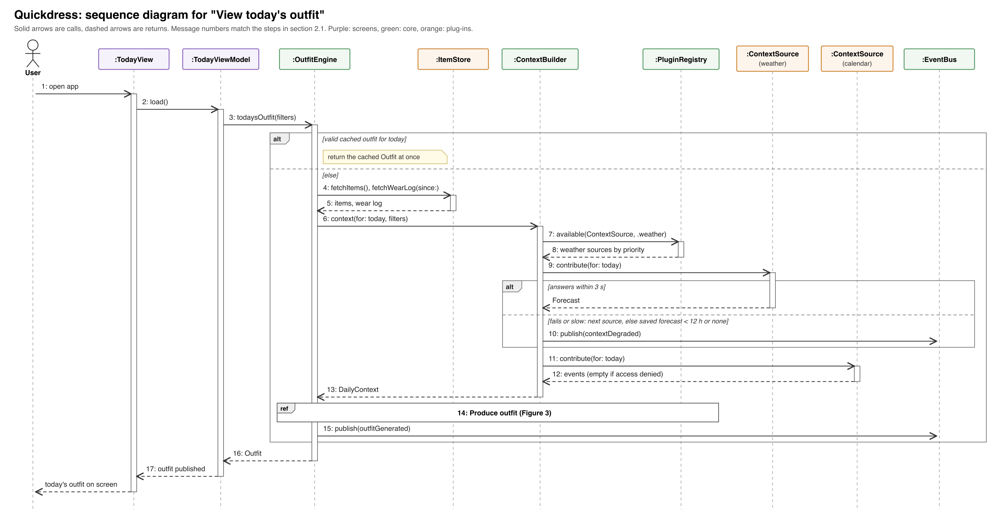
Figure 2. Sequence diagram for "View today's outfit" (FR-05, FR-08, FR-11, NFR-01, NFR-03). The step inside the engine is shown in Figure 3.
Figure 2 shows the main use case. The numbers in brackets are the message numbers in the figure.
- The user opens the app and TodayViewModel.load() calls OutfitEngine.todaysOutfit(filters) (1 to 3).
- If an outfit was already generated today and nothing it depends on has changed, the engine returns it from its cache at once. The cache is saved through the ItemStore, so it survives a relaunch and the screen is never blank (NFR-01). The rest of the steps run only when there is no valid cached outfit.
- The engine loads the items and the wear log for the no-repeat period from the ItemStore (4, 5).
- It asks ContextBuilder for today's DailyContext (6). The builder asks the registry for the available weather sources in priority order (7, 8) and calls the first one (9). If it fails or takes more than 3 seconds, the builder tries the next one. If every source fails, it uses the last saved forecast if it is less than 12 hours old, and otherwise uses no forecast. Either way it publishes contextDegraded, and the Today screen shows a badge (10). If location permission is denied, the weather sources report themselves unavailable and the outfit is chosen for mild weather, with a note on screen.
- The builder reads today's events from the calendar source (11, 12). If calendar access is denied, the list is empty and formality comes only from the filters (NFR-07). It then works out the day's formality level (section 2.2) and returns the context (13).
- The engine runs the pipeline and the recommenders (14), shown in detail in Figure 3, saves the result as today's outfit and publishes outfitGenerated (15). The ViewModel returns the outfit to the view, which draws it (16, 17).
Swapping a piece (FR-06) calls OutfitEngine.alternatives(for: slot). The engine returns the next three items for that slot in the rule-based ranking, keeping the other pieces fixed. Swaps never call Gemini, so they are instant and free. Asking for a new outfit (FR-07) runs the pipeline again with the current outfit added to the excluded combinations. Marking an outfit as worn (FR-09) calls OutfitEngine.markWorn(), which writes a WearRecord through the ItemStore and publishes outfitWorn.

2.2 Inside the outfit engine: the pipeline and the recommender plug-ins
The engine is a pipe-and-filter pipeline. Each stage takes the candidate items for every slot and passes a smaller set to the next stage. Figure 3 shows both cases: Gemini available and answering, and Gemini off, offline or failing, when the rule-based plug-in answers.
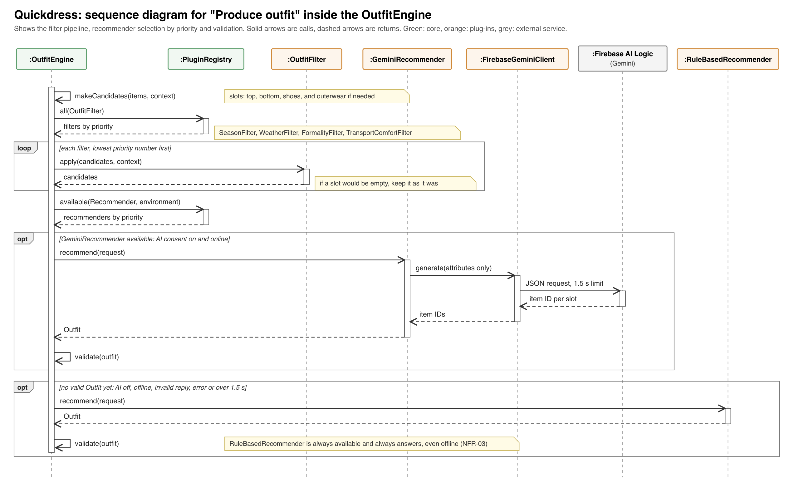
Figure 3. Sequence diagram for "Produce outfit" inside the OutfitEngine: filter pipeline, recommender selection by priority, and validation (FR-05, FR-08 to FR-11, FR-22, NFR-02, NFR-03, NFR-05, NFR-08).

Stage 1: candidates
Items are grouped into slots: top, bottom, shoes and, when needed, outerwear. Accessories are not part of this term's outfits. Outerwear is needed when the day's average apparent temperature is below 17 °C or the chance of rain is 50% or more.

Stage 2: filters
Every registered filter runs in priority order. If a filter would leave a slot empty, the engine keeps that slot as it was before the filter and notes that the filter was relaxed. This is why the app always produces an outfit as long as the wardrobe has at least one top, one bottom and one pair of shoes.
Filter | Rule
SeasonFilter | Keeps items whose seasons include the current one. Seasons follow the calendar months: December to February is winter, March to May spring, June to August summer and September to November autumn.
WeatherFilter | Works out a target warmth level from the average apparent (feels-like) temperature between 08:00 and 20:00: 30 °C and above gives 1, 24 to 29 °C gives 2, 17 to 23 °C gives 3, 10 to 16 °C gives 4, and below 10 °C gives 5. Keeps tops, bottoms and outerwear within one level of the target. With no forecast, the target is 3.
FormalityFilter | Keeps items within one level of the day's formality. The day's formality is the override from the filters if the user set one. Otherwise it is 4 if any event today is tagged formal by the user or its title contains a formality keyword, and 2 if not.
TransportComfortFilter | When the transport mode is walking or public transport, removes shoes with comfort below 3. When the comfort priority is high, removes every item with comfort below 3.
Table 5. The four filters in pipeline order.
The formality keywords are kept in one file, FormalityKeywords.swift, and matching ignores case. The first list is: interview, presentation, defense, defence, viva, conference, ceremony, graduation, wedding, formal, and the Arabic words مقابلة (interview), عرض (presentation), مؤتمر (conference), حفل (ceremony), تخرج (graduation) and فرح (wedding). Risk R7 covers the cases this list will miss.

Stage 3: recommenders
The engine builds an OutfitRequest with the filtered candidates, the context, and the combinations worn within the no-repeat period, which are excluded. It then asks the available recommenders in priority order. Each answer is checked: every slot that is needed must have exactly one item, every item must come from the candidates, and the combination must not be excluded. If an answer fails the check, throws an error or takes longer than 1.5 seconds, the engine asks the next recommender. The rule-based recommender is always last and always answers, so the app needs no network to produce an outfit (NFR-03).
The rule-based recommender scores each candidate on its own, keeps the best five per slot, and then scores the combinations:
- Item score = 0.4 × warmth fit + 0.3 × formality fit + 0.2 × (comfort ÷ 5) + 0.1 × freshness. Warmth fit is 1 minus the gap between the item's warmth and the target, divided by 4. Formality fit works the same way. Freshness is the number of days since the item was last worn, capped at 14 and divided by 14; an item never worn scores 1.
- Combination score = 0.7 × the average item score + 0.3 × the colour score. The colour score is the average over every pair of pieces in the outfit, read from a 12 × 12 colour table. Any colour paired with a neutral (black, white, grey, navy, beige) scores 1.0. Two pieces of the same non-neutral colour score 0.6. Pairs listed as clashing (red with pink, red with green, orange with pink, purple with yellow) score 0.2. Every other pair scores 0.5. The full table is written in Sprint 2 in ColourTable.swift.
- Five candidates in each of four slots give at most 625 combinations, however large the wardrobe is, which keeps generation under the one-second limit in NFR-05. Ties go to the combination with the higher freshness.
The weights above are the starting values. They are constants in one file, ScoringWeights.swift, and the team changes them only once, after the Sprint 2 usability test (Table 6), based on which outfits the testers rejected.
Worked example. The forecast gives an average apparent temperature of 21 °C with a 10% chance of rain, and the calendar has "Group presentation" at 10:00. The target warmth is 3, no outerwear is needed, and the formality is 4 because of the keyword "presentation". SeasonFilter, WeatherFilter and FormalityFilter leave, say, 6 tops, 4 bottoms and 3 pairs of shoes. If Gemini is turned off or the phone is offline, the rule-based recommender scores the 6 × 4 × 3 = 72 combinations and returns the best one that was not worn in the last 7 days.

2.3 Adding a clothing item
The Add item screen asks the registry for the available image sources and shows one button for each. On the Simulator, CameraSource reports itself unavailable, so only the photo library is offered (R10). When the user taps a source, the source asks for permission if it needs it (the camera does, PhotosPicker does not) and returns the photo as JPEG data, scaled so that its long edge is at most 1600 pixels. If the stretch analyzer is built (FR-13), it suggests a category and a colour, which the user confirms or changes. The user sets the other attributes and taps Save.
WardrobeManager.addItem validates the attributes, asks the PhotoStore to write the photo and gets back a reference, then saves the item with that reference through the ItemStore. If saving the item fails, the manager deletes the photo it has just written, so no orphan files are left behind (NFR-06). It then publishes itemSaved. Deleting an item runs in the opposite order and publishes itemDeleted, which makes the engine replace today's outfit if the item was in it. The detailed design of the capture screens is a separate deliverable.

The Gemini plug-in and what it sends
GeminiRecommender reports itself available only when the AI switch is on and the phone is online. The switch is off by default, and the Settings screen explains in one sentence what is sent before the user can turn it on. This is the explicit consent that NFR-02 requires. When it runs, its client, FirebaseGeminiClient, sends:
- for each candidate item that passed the filters: its ID, category, colour, warmth, formality, comfort and seasons;
- for the day: the target warmth, whether outerwear is needed, the formality level, the transport mode and the comfort priority;
- the excluded combinations, as lists of item IDs.
It never sends photos, item names, calendar event titles or the user's location. Gemini is asked for structured JSON output that names one item ID per slot. The engine's check (stage 3) rejects any reply that does not fit. The model name is stored in Firebase Remote Config, so it can be changed without an app update. The plug-in uses Firebase AI Logic rather than calling the Gemini API directly, because a direct call would mean shipping an API key inside the app, where it can be extracted. Firebase keeps the key on Google's side and uses App Check (App Attest on iOS) to accept requests only from genuine copies of our app.

2.4 Alternatives considered
Alternative | Why we did not choose it
Layered architecture (our first version) | It grouped components by technical level, but it had no place for the main thing Quickdress does: choosing between interchangeable sources and recommenders at run time, with a fallback when one fails. That logic was spread across a relaxed set of layers in which ViewModels could skip the domain layer. The instructor also judged it too simple for the app.
Hexagonal (ports and adapters) | Close to what we have, but it expects one adapter per port, chosen when the app is built. We need several plug-ins per contract, chosen at run time by priority and availability, which is what a microkernel's registry provides.
Event-driven architecture on its own | Showing today's outfit is a request that needs an answer within 2 seconds (NFR-01). Building that from events and handlers would make the main flow hard to follow and test. We use events only for notifications (Table 4).
Client and server with our own backend | It would allow syncing and a server-side model, but it breaks on-device privacy (NFR-02), needs hosting and user accounts, and adds a second codebase. iCloud sync is out of scope this term (FR-21).
Model, View, Controller (MVC) for the screens | SwiftUI has no view controllers, so in practice the logic ends up inside the views, where it is hard to test. MVVM fits SwiftUI's @Observable data binding directly.

3 Quality attributes and how we will test them
Table 6 shows how the architecture meets each non-functional requirement in scope, and how and when we will check it. Every test runs in the sprint named, and its result is recorded in the sprint's test log in the GitHub repository (docs/test-log.md).
Requirement | How the architecture addresses it | Test: when, how, and the pass mark
NFR-01  Outfit visible within 2 s | The engine's cache returns today's outfit at once. The pipeline runs off the main thread. Recommenders other than the rule-based one get at most 1.5 s, and context sources 3 s each. | Sprint 2. Launch-to-outfit time measured with Instruments (os_signpost markers) on the oldest iPhone the team has, with a 200-item test wardrobe created by TestWardrobeFactory. Pass: under 2 s in 9 of 10 cold launches.
NFR-02  Data stays on the device | Every store is local. The only plug-in that sends wardrobe data is GeminiRecommender, it sends attributes only, and it is unavailable without consent. Weather plug-ins send only an approximate location. | Sprint 3. Run the app through the Proxyman proxy with consent off and on. Pass: with consent off, only weather requests appear; with it on, the Gemini request contains none of the fields listed as never sent (section 2.3).
NFR-03  Works offline | The rule-based recommender is always the last plug-in and needs no network. The context builder falls back to the saved forecast or to defaults. | Every sprint demo, plus an XCTest that registers only failing context sources. Pass: in airplane mode the wardrobe opens and an outfit appears.
NFR-04  First outfit within 5 minutes | Two tabs (Today, Wardrobe). The Today screen shows an Add item button, not an error, until a top, a bottom and shoes exist. | End of Sprint 2. Five people from outside the team, given a phone with an empty wardrobe and no instructions. Pass: at least 4 of 5 see an outfit within 5 minutes.
NFR-05  Under 1 s for 200 items | The shortlist of five per slot caps the work at 625 combinations (section 2.2). The scorer is a pure Swift function. | From Sprint 2, an XCTest measure test on 200 generated items, run by GitHub Actions on every pull request. Pass: average under 1 s.
NFR-06  No data lost | Photo first, item second, with rollback. Files in Application Support, which iOS does not clear. | End of every sprint: force-quit during a save, and install the new build over the previous one. Pass: every item and photo is still there and no orphan files exist.
NFR-07  Permissions on first use | Each plug-in asks for its own permission the first time it is used and reports itself unavailable if it is denied. The core treats an unavailable plug-in the same as a failed one. | End of Sprints 2 and 3: deny camera, location and calendar in turn. Pass: the app still adds items from the library and still shows an outfit, with the matching note.
NFR-08  Swappable recommender | Recommenders are plug-ins behind one contract. The ViewModel never knows which one answered. | From Sprint 2, an XCTest registers a fake recommender with a higher priority. Pass: its outfit is shown without any change to the app's code.
Table 6. Non-functional requirements, the decisions that meet them, and the test plan.
NFR-09 to NFR-11 are not formally tested this term, but the design supports them. Standard SwiftUI controls work with VoiceOver and Dynamic Type, and every item photo gets an accessibility label made from its category and colour. Strings go in a String Catalog so Arabic can be added later. The deployment target is iOS 17, which SwiftData and @Observable need anyway.

4 Architectural and design patterns
Four architectural patterns shape the app: the microkernel as a whole, pipe and filter inside the engine, publish and subscribe for events, and MVVM for the screens. Six design patterns shape individual parts. For each one, the table gives what the pattern is, where we use it, and why it suits Quickdress.

4.1 Architectural patterns

Microkernel (plug-in architecture)
What it is | A minimal core system holds the stable rules and a registry. Optional, replaceable features are plug-ins that implement contracts defined by the core.
Where it is used | QuickdressCore with PluginRegistry, and the five kinds of plug-in contract and their plug-ins (Tables 2 and 3, Figure 1).
Why it fits | Quickdress's variability is in its interchangeable parts: two weather sources, two recommenders with a fallback, two image sources and four filters, with more already in the backlog. Each becomes a plug-in, so adding one (for example OpenMeteoSource if WeatherKit is not available) changes no core code and no screen.

Pipe and filter
What it is | Data passes through a sequence of independent stages, each of which takes input and produces output for the next stage.
Where it is used | The outfit engine: candidates, then SeasonFilter, WeatherFilter, FormalityFilter and TransportComfortFilter, then the recommenders, then validation (section 2.2, Figure 3).
Why it fits | Each rule of the recommendation is a small stage that can be tested alone with a handful of items. A new rule, such as the planned laundry filter (FR-20), is one more stage.

Publish and subscribe (event bus)
What it is | Components publish events to a bus without knowing who receives them. Subscribers register for the events they care about.
Where it is used | EventBus and the six events in Table 4.
Why it fits | When an item is deleted, the engine, the wardrobe screen and today's outfit all need to react. With events, WardrobeManager does not need to know about any of them.

Model, View, ViewModel (MVVM)
What it is | The View displays state, the ViewModel holds that state and the actions on it, and the Model is the data. The View observes the ViewModel and redraws when the state changes.
Where it is used | Every screen in the host app: TodayView with TodayViewModel, WardrobeView and AddItemView with WardrobeViewModel, FiltersView with FiltersViewModel, and SettingsView with SettingsViewModel. ViewModels are @Observable classes.
Why it fits | SwiftUI is built around this kind of binding. ViewModels can be tested without any UI, and they depend only on the core's services.

4.2 Design patterns

Strategy
What it is | A family of interchangeable algorithms behind one interface, so the caller can use any of them without knowing which.
Where it is used | The Recommender contract, with RuleBasedRecommender and GeminiRecommender. The ContextSource contract, with WeatherKitSource and OpenMeteoSource.
Why it fits | NFR-08 asks for this directly. The engine picks the strategy at run time from the registry, by priority and availability.

Plugin and Registry
What it is | Plugin links an implementation to an interface at configuration time rather than in the code that uses it. A registry is a well-known object that other objects use to find those implementations.
Where it is used | QuickdressApp registers every plug-in in one place. PluginRegistry.available(Recommender.self) returns the available recommenders in priority order.
Why it fits | The choice of plug-ins is made in one file, so the order of the fallback and the set of filters is configuration, not code spread across classes.

Adapter
What it is | A class that wraps an existing interface so it matches the interface a client expects.
Where it is used | WeatherKitSource, OpenMeteoSource, EventKitCalendarSource, CameraSource, PhotoLibrarySource and FirebaseGeminiClient wrap Apple, Google and Open-Meteo interfaces and convert their types into our Forecast, CalendarEvent and JPEG data.
Why it fits | SDK types never reach the core, which is why the core can stay Foundation-only.

Repository
What it is | An object that behaves like a collection of domain objects and hides how they are stored.
Where it is used | The ItemStore contract and SwiftDataItemStore, which keeps its own @Model records and maps them to the domain types.
Why it fits | All queries and the SwiftData ModelContext live in one plug-in. Tests use an in-memory store. Moving to Core Data (risk R8) or CloudKit (FR-21) means writing one new plug-in.

Observer
What it is | An object notifies its observers automatically when its state changes.
Where it is used | SwiftUI views observe their @Observable ViewModels. The event bus applies the same idea between the core and the ViewModels.
Why it fits | It keeps the screens in step with the data without the core ever calling a view.

Dependency injection
What it is | Objects receive the things they depend on from outside instead of creating them.
Where it is used | QuickdressApp creates the registry, the event bus, the plug-ins and the core services, and passes the services to the ViewModels through their initialisers.
Why it fits | It lets tests and previews use fakes for every plug-in, which is how the tests in Table 6 run without a network or real permissions.

5 Detailed design: class diagram
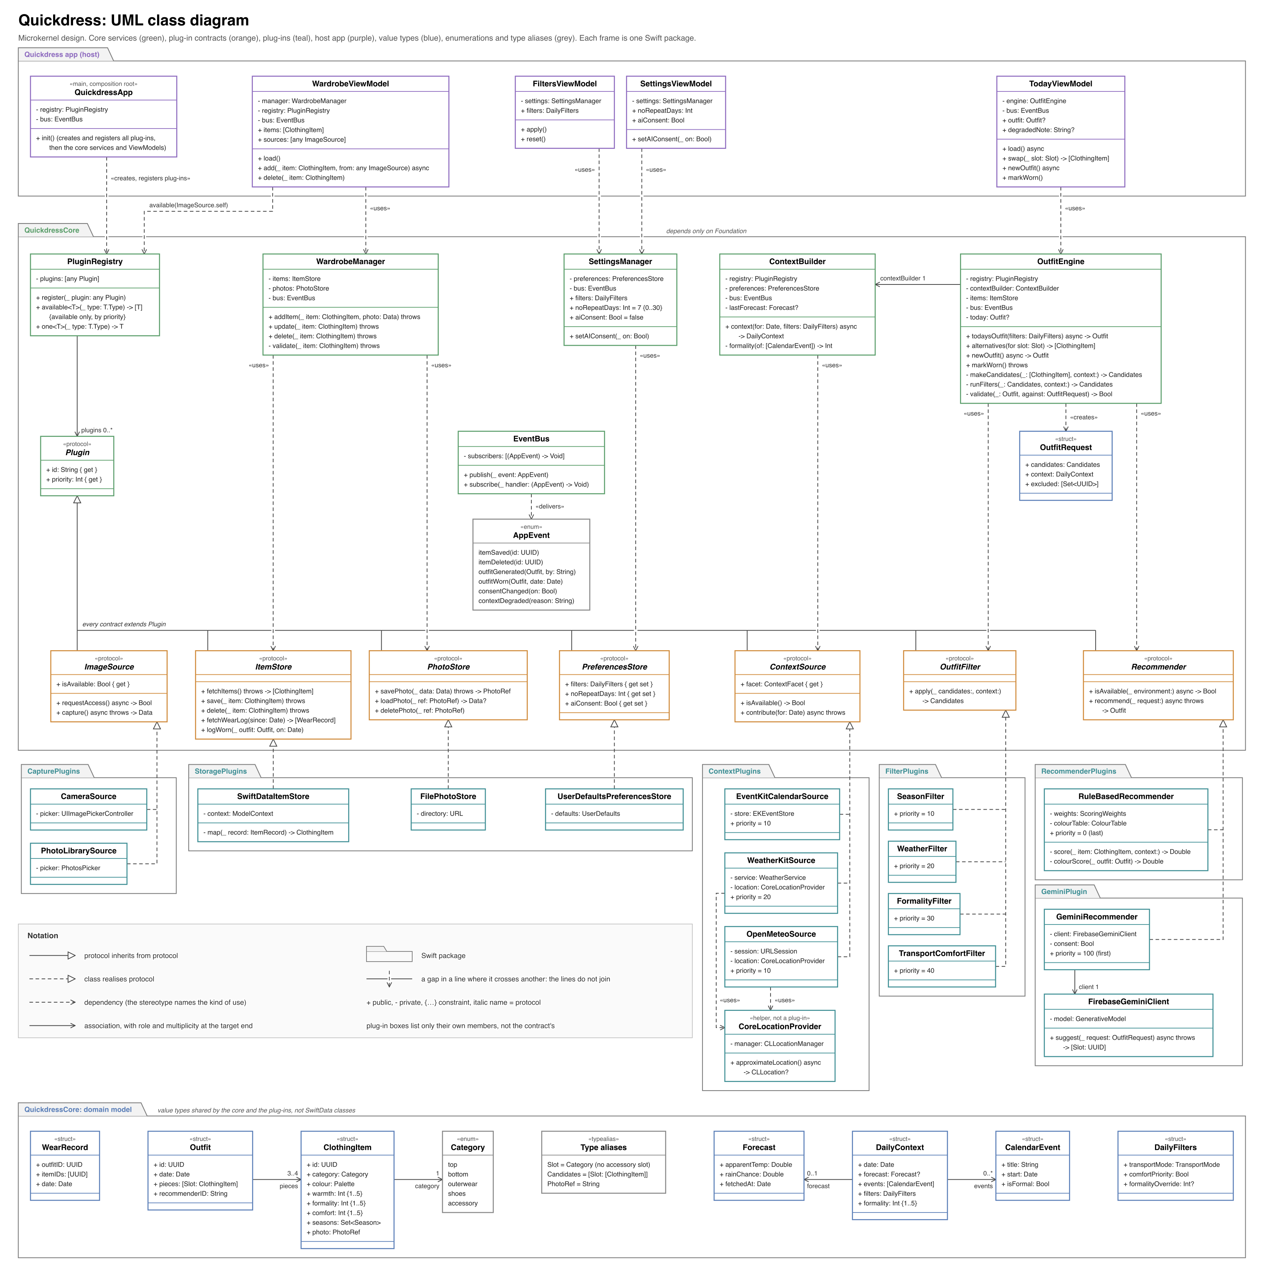
Figure 4. UML class diagram (Swift types). The components in Figure 1 are made up of these classes.
Table 7 maps each component in Figure 1 to its classes in Figure 4, and names the Swift package each belongs to.
Component | Package | Classes in Figure 4
PluginRegistry | QuickdressCore | Plugin, PluginRegistry
EventBus | QuickdressCore | EventBus, AppEvent
WardrobeManager | QuickdressCore | WardrobeManager
ContextBuilder | QuickdressCore | ContextBuilder
OutfitEngine | QuickdressCore | OutfitEngine, OutfitRequest
SettingsManager | QuickdressCore | SettingsManager
Plug-in contracts | QuickdressCore | ImageSource, ItemStore, PhotoStore, PreferencesStore, ContextSource, OutfitFilter, Recommender
Domain model | QuickdressCore | ClothingItem, Outfit, WearRecord, DailyContext, DailyFilters, Forecast, CalendarEvent, Category, Slot
Capture plug-ins | CapturePlugins | CameraSource, PhotoLibrarySource (and ItemAnalyzer, a stretch helper used by the Add item screen, not drawn)
Storage plug-ins | StoragePlugins | SwiftDataItemStore, FilePhotoStore, UserDefaultsPreferencesStore
Context plug-ins | ContextPlugins | WeatherKitSource, OpenMeteoSource, EventKitCalendarSource, CoreLocationProvider
Filter plug-ins | FilterPlugins | SeasonFilter, WeatherFilter, FormalityFilter, TransportComfortFilter
Recommender plug-ins | RecommenderPlugins, GeminiPlugin | RuleBasedRecommender, GeminiRecommender, FirebaseGeminiClient
Screens (host app) | Quickdress app | TodayViewModel, WardrobeViewModel, FiltersViewModel, SettingsViewModel, QuickdressApp
Table 7. Mapping from components to packages and classes.
GeminiRecommender has its own package so that the Firebase SDK is linked only into that package. Every contract is drawn with the plug-ins that realise it. Dependencies that a class holds as a typed attribute, such as OutfitEngine.registry, are listed in the class box; only the main ones are drawn as arrows to keep the diagram readable.

6 Technical feasibility, build order and risks

6.1 Feasibility
Every in-scope feature uses well-documented first-party Apple frameworks: SwiftUI, SwiftData, PhotosUI, AVFoundation, WeatherKit, EventKit and Core Location, or the free Open-Meteo API. The only third-party SDK is Firebase, used only by the stretch Gemini plug-in. The hardest algorithm, the recommender, is rule-based scoring in plain Swift with the rules written out in section 2.2.
The microkernel adds two components that a layered design does not have: the registry and the event bus. Both are small. The registry is a dictionary from contract to a sorted list of plug-ins, and the bus is a list of handlers per event. We keep them under 150 lines together, and they are built and tested in the first week of Sprint 1, before any plug-in. Because plug-ins are compiled in, not loaded at run time, there is no dynamic loading to get right.

6.2 Build order
Each sprint ends at the next course milestone and delivers a working app that can be demonstrated. Table 8 lists what each sprint builds and the exit criteria that must pass before the sprint counts as done. Each person owns whole plug-ins, which is possible because plug-ins do not depend on each other.
Sprint | Components built | Exit criteria
Sprint 1 | Core: PluginRegistry, EventBus, WardrobeManager, domain model. Plug-ins: CameraSource, PhotoLibrarySource, SwiftDataItemStore, FilePhotoStore. Host app: Wardrobe screens. | FR-01 to FR-04 shown in the demo. Unit tests for WardrobeManager (validation and photo rollback) pass with in-memory stores. The NFR-06 test passes.
Sprint 2 | Core: ContextBuilder, OutfitEngine, SettingsManager. Plug-ins: OpenMeteoSource (and WeatherKitSource if R1 allows), SeasonFilter, WeatherFilter, RuleBasedRecommender, UserDefaultsPreferencesStore. Host app: Today screen. | FR-05 to FR-08 shown in the demo. The NFR-01, NFR-03, NFR-04, NFR-05, NFR-07 and NFR-08 tests in Table 6 pass.
Sprint 3 | Plug-ins: EventKitCalendarSource, FormalityFilter, TransportComfortFilter. Core: wear log and no-repeat period. Host app: Filters screen. | FR-09 to FR-11 shown in the demo. The NFR-02, NFR-03, NFR-06 and NFR-07 tests pass.
Sprint 3 stretch | In this order: saved outfits (FR-12), ItemAnalyzer (FR-13), GeminiRecommender and the Settings screen (FR-22). | Started only if every Sprint 2 exit criterion has passed when Sprint 3 begins. A stretch item that is not merged one week before the Sprint 3 demo is dropped. ItemAnalyzer ships only if it suggests the right category for at least 24 of 30 of the team's own items.
Table 8. Build order and exit criteria by sprint.
Every change goes through a pull request on GitHub. The main branch is protected: a pull request needs one approving review from another team member and a passing GitHub Actions run (build plus all tests) before it can be merged.

6.3 Risks
ID | Risk | Chance | Impact | Mitigation | Decided by
R1 | WeatherKit needs a paid Apple Developer Program membership ($99 a year). Without one, test installs also expire every 7 days. | High | High: blocks FR-08 | OpenMeteoSource (free for non-commercial use, no key) is built in Sprint 2 regardless. WeatherKitSource is added only if a membership exists, as a higher-priority plug-in. | Start of Sprint 2
R2 | Xcode runs only on macOS. A team member without a Mac cannot build or run the app. | Medium | High | Pair those members with Mac owners, or give them work that needs no Xcode: the colour table, the keyword list, the 200-item test data and the test plans in Table 6. | Start of Sprint 1
R3 | The team is learning Swift and SwiftUI during the project. | High | Medium | Sprint 1 is plain create, read, update and delete work. Each plug-in is small and has one owner. Every pull request is reviewed. | Ongoing
R4 | The plug-in structure is new to the team and could slow Sprint 1. | Medium | Medium | Registry and bus under 150 lines, built first with tests. No dynamic loading. After the Sprint 1 review, a change to a contract needs the agreement of the whole team in the pull request. | End of Sprint 1 week 1
R5 | Gemini replies may be wrong, slow or not valid JSON. | Medium | Low | Structured output, the engine's validation, a 1.5 s limit and the rule-based fallback. | Sprint 3 (stretch)
R6 | Gemini cost, quota or model names change. | Low | Low | Flash-Lite is Google's lowest-cost model in the family. The model name is in Remote Config. At most one call per generated outfit, and none for swaps. | Sprint 3 (stretch)
R7 | Detecting formality from calendar titles by keyword misses vague titles such as "Meeting". | High | Medium | The user can tag an event as formal, and the formality override always wins. The keyword list (section 2.2) is in one file. | Sprint 3
R8 | SwiftData is fairly new and has known bugs, especially with schema changes. | Medium | Medium | SwiftData is used only inside SwiftDataItemStore. If it fails the NFR-06 test twice, we replace that one plug-in with a Core Data version. | End of Sprint 1
R9 | Automatic category and colour suggestion (FR-13) may be inaccurate. | Medium | Low | Stretch goal with a pass mark of 24 correct out of 30 (Table 8). The user always confirms the suggestion. | Sprint 3 (stretch)
R10 | The iOS Simulator has no camera. | Certain | Low | CameraSource reports itself unavailable on the Simulator, so the photo library is used there. The camera is tested on a real phone. | Sprint 1
R11 | Event handlers could run in an unexpected order or trigger each other in a loop. | Low | Medium | Handlers run in subscription order on the main thread, may not publish the same event type, and each event has a unit test. | Sprint 1
Table 9. Technical risks.
Core ML is no longer part of this term's plan. We have no training data, so a model could not be tested. The design keeps the option open: an on-device recommender would be one more plug-in (Table 3).

7 Conclusion
Quickdress is built as a microkernel. A small, Foundation-only core holds the wardrobe rules, the context builder, the outfit engine, a plug-in registry and an event bus. Everything that varies is a plug-in: image sources, stores, weather and calendar sources, outfit filters and recommenders. Inside the engine, a pipe-and-filter pipeline narrows the wardrobe, and recommenders are tried by priority with a rule-based plug-in that always answers, which is how the design meets the offline and privacy requirements while still allowing the opt-in Gemini step. The screens use MVVM and talk only to the core. Section 2.2 writes out the recommendation rules, Table 6 gives a test with a pass mark for each of NFR-01 to NFR-08, and Table 8 sets exit criteria for each sprint and a rule for when stretch goals are built.
Part C
Presentation

Presentation outline
The milestone asks the presentation to cover a fixed list of topics. The deck itself is the separate file Quickdress_Milestone1_Presentation.pptx. Table C1 shows where each required topic is covered, the points to make, and where the material comes from.
# | Slide | Points to make | Source / figure
1 | Title | Quickdress, team names, Milestone 1. | None
2 | What it is and the problem | An iOS app that recommends one outfit a day from clothes you already own, matched to weather and calendar. | Part A, 1.1 and 1.2
3 | Users and stakeholders | Students, young professionals, people with decision anxiety, people unsure about colour. Stakeholders: users, team, instructor and TAs, Apple, weather provider, Google (only for the opt-in AI step). | Part A, 1.3 and 1.4
4 | Motivation | Cladwell and Acloset already suggest daily outfits from the weather. Quickdress differs in four choices: on the phone with no account, transport and comfort filters, calendar formality the user can correct, and free. A Sprint 1 check will confirm which of these the other apps lack. | Part A, 1.5
5 | Product backlog | 22 functional and 11 non-functional requirements, prioritised with MoSCoW. | Part A, section 2
6 | Scope | FR-01 to FR-11 and NFR-01 to NFR-08 committed; FR-12, FR-13 and FR-22 are stretch goals; FR-14 to FR-21 deferred. | Part A, section 3
7 | Why the scope is achievable | Three sprints, one per milestone, each with exit criteria. The outfit engine sits in the middle sprint, and its rules are written out. Stretch goals follow a fixed decision rule. | Part A, Figure 1 (sprint plan)
8 | Use cases | One primary actor, three secondary actors, twelve use cases. Walk through "View today's outfit". | Part A, Figure 2 (use case diagram)
9 | High-level architecture | Microkernel: a Foundation-only core with a plug-in registry and an event bus. Plug-ins for capture, storage, context, filters and recommenders. MVVM screens talk only to the core. | Part B, Figure 1 (component diagram)
10 | How it works | The "View today's outfit" flow, then the outfit engine: a filter pipeline, then recommenders tried by priority (opt-in Gemini first, rule-based last, which always answers and needs no network). | Part B, Figures 2 and 3
11 | Quality attributes and patterns | How the design meets each NFR and how and when each is tested. Patterns: microkernel, pipe and filter, publish and subscribe, MVVM, Strategy, Plugin and Registry, Adapter, Repository, Observer, dependency injection. | Part B, sections 3 and 4
12 | Technical risks | Open-Meteo is built regardless and WeatherKit only with a paid membership; Xcode needs a Mac; the team is learning Swift and the plug-in structure; calendar keyword detection misses vague titles. Each risk has a decision point. | Part B, Table 9
13 | Global and social considerations | Privacy first (on-device data), weather-related health, modest-dress and cultural norms, re-wearing instead of buying, free app with no shopping links. | Part A, section 5
14 | Conclusion | What Milestone 1 fixes (baseline requirements and architecture) and what Sprint 1 delivers next (a working digital wardrobe). | Part A, section 6
Table C1. Presentation outline.

